IBM JAVA FSD CLOUD NATIVE TRAINING PROJECT

**Project Name:-** The Project Manager Single Page Application.

**Trainer:-** Nilay Das

**Author:-** Umme Athiya

**Project Problem Definition:-**

The Project Manager Single Page Application allows you to manage projects and their respective tasks. It allows you to set priorities to each project and task. You can associate one manager to each project and task-owner for each task. Each task will have parent task, start date, end date and task owner. Below are the features of Project Manager:

1. Add/Edit/View/Delete User
2. Add/Edit/View/Delete Project
3. Add/Edit/View/Delete Task
4. You can make one task a parent of another task.
5. On view task screen:
   1. MO
   2. User can edit task
   3. User can end the task once it is finished. Once ended, user cannot edit the task. User can only view the task once finished.

**Object Diagram:-**

Micro services

Instances down  
Load Balancing

Project Management App

Project Microservice

Task Microservice

User Microservice

MySQL  
Database

Zuul Proxy Server

Admin Server

Eureka Server

**Project Snapshots:-**

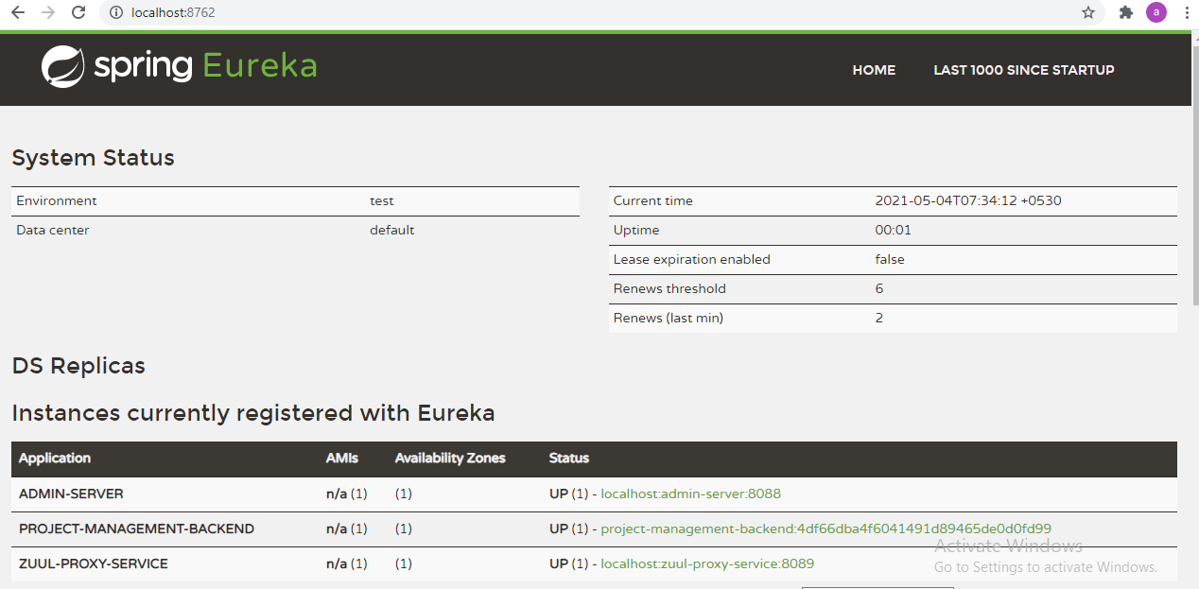

**Figure 1:- Eureka Instances Registered.**

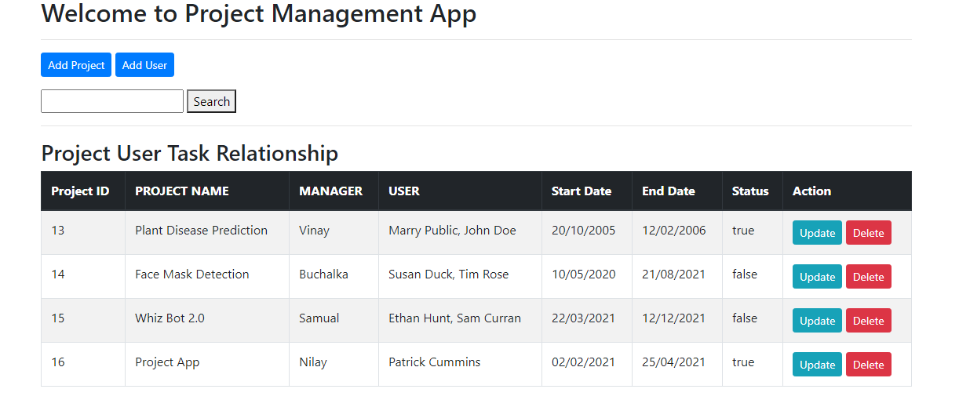

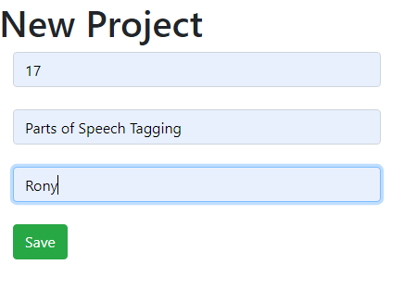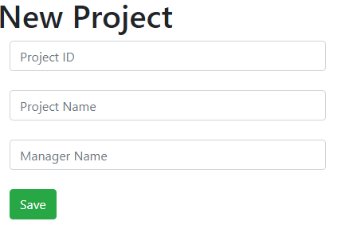 **Figure 2:- Front End of Project Management System.**

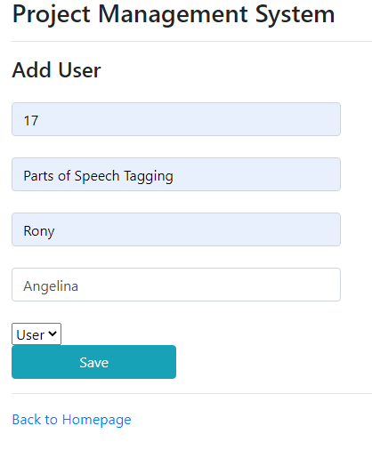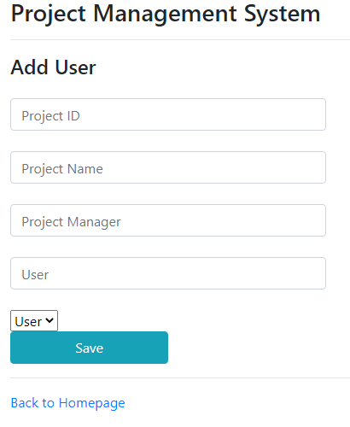

**Figure 4:- Adding User**

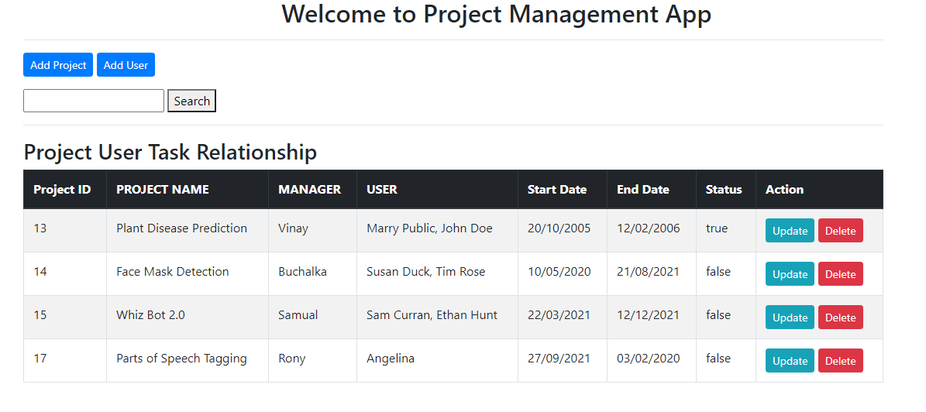 **Figure 5:- Deleted Project**

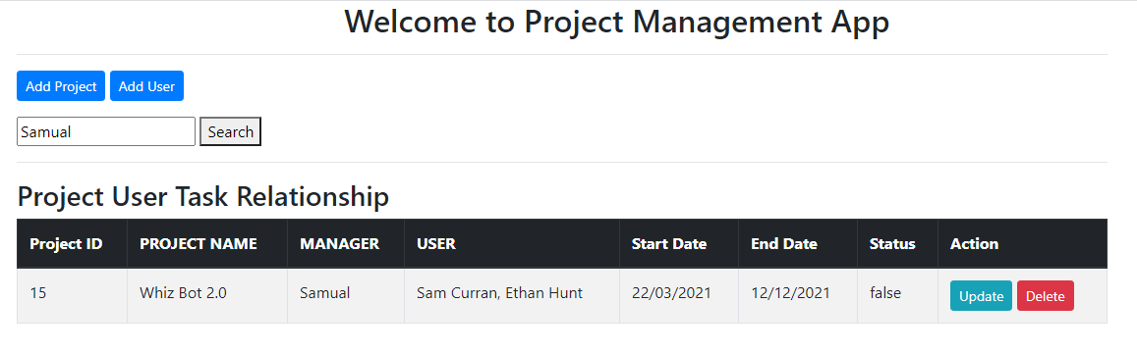

**Figure 6:-Search Project**

**Postman Snapshots:-**

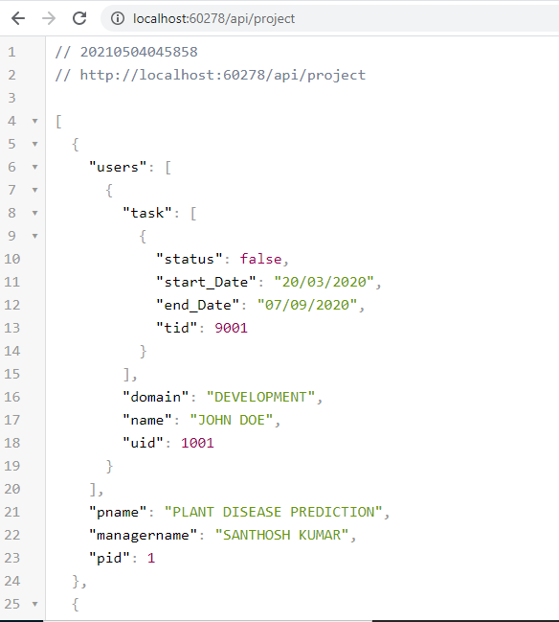

**Figure 7:- Get all details (One to Many Mapping)**

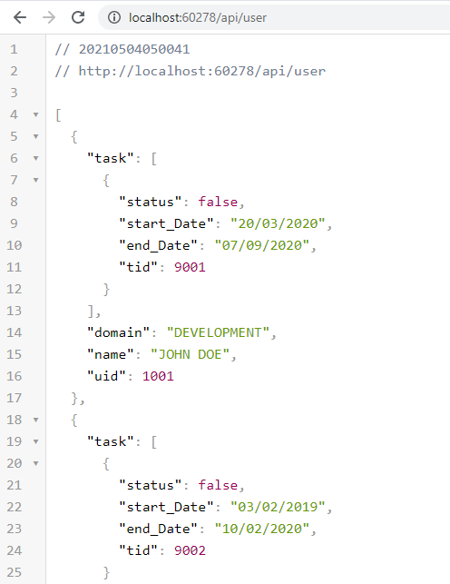

**Figure 8:- Get all the user details**

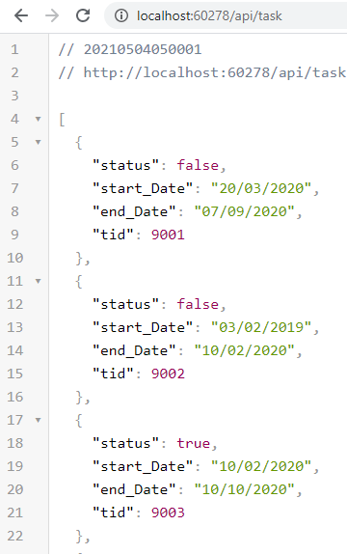

**Figure 9:- Get all the task details.**

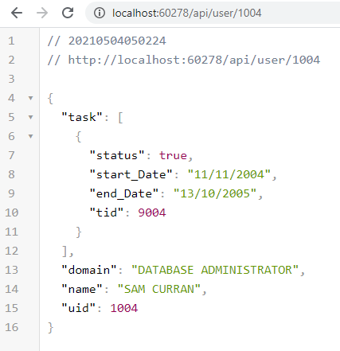

**Figure 10:- Get by Id – User**.

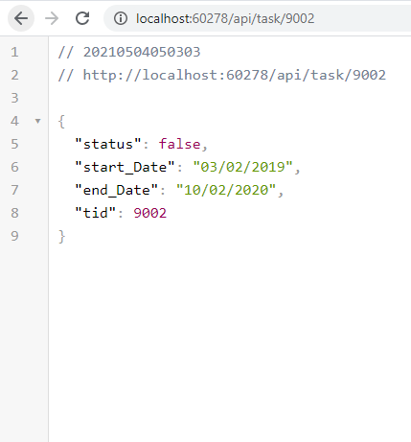

**Figure 11:- Get by Id – Task.**

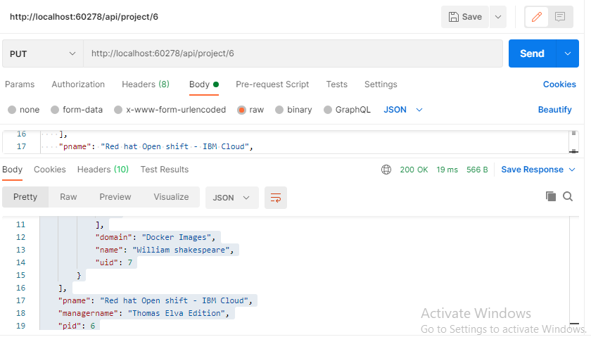

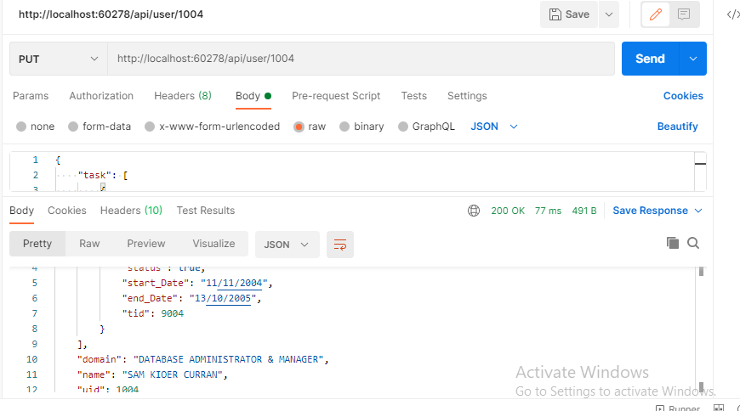 **Figure 12:- Update Project.**

**Figure 13:- Update User.**

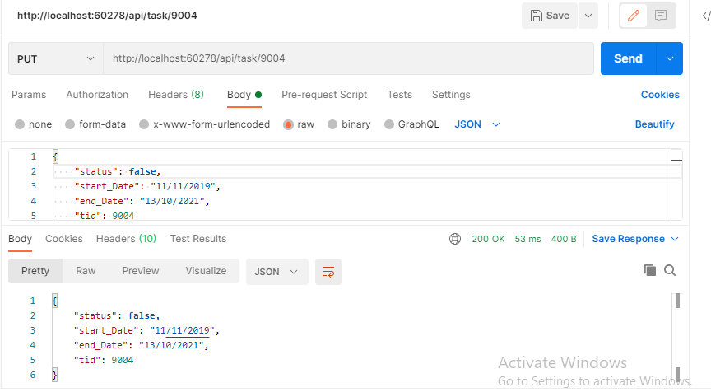

**Figure 14:- Update Task.**

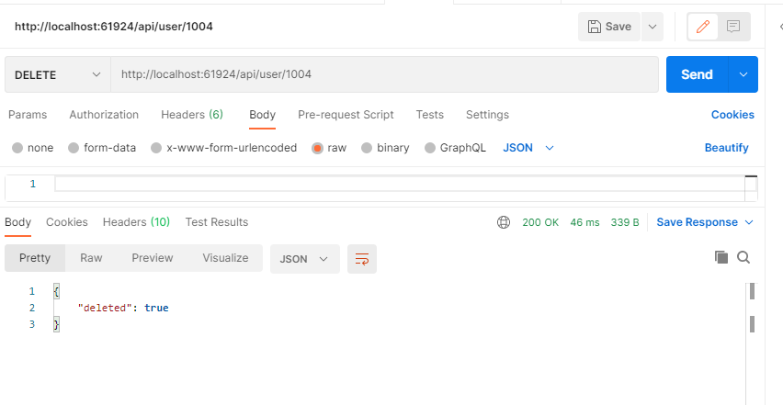

**Figure 15:- Delete User.**

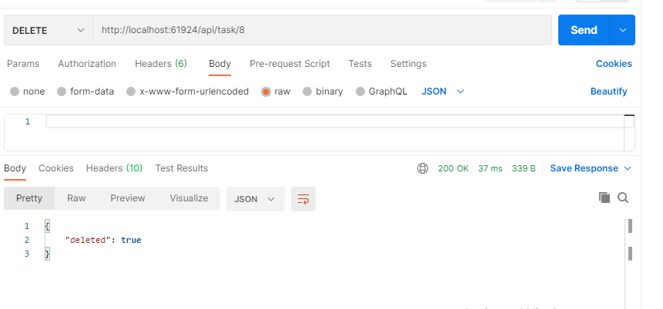

**Figure 16:- Delete Task.**

**Source Code:-**

**Google Drive link:-** [**https://drive.google.com/file/d/19IyCML3HMIDPE9g1_EPu-6Q_nxvZ0YyS/view?usp=sharing**](https://drive.google.com/file/d/19IyCML3HMIDPE9g1_EPu-6Q_nxvZ0YyS/view?usp=sharing)

**Github Link:-** [**https://github.com/UMMEATHIYA/IBM-Project.git**](https://github.com/UMMEATHIYA/IBM-Project.git)

**Thank You**